QUESTION 1
- In this image, you can see the original musical score for the “canto” (or soprano) part of this piece. Look closely at the melody in the first line of music and click on part of the melody where you see disjunct motion. (For your answer to be recorded correctly, you should simply click on one of the notes where you see disjunct motion. There are multiple correct answers!)
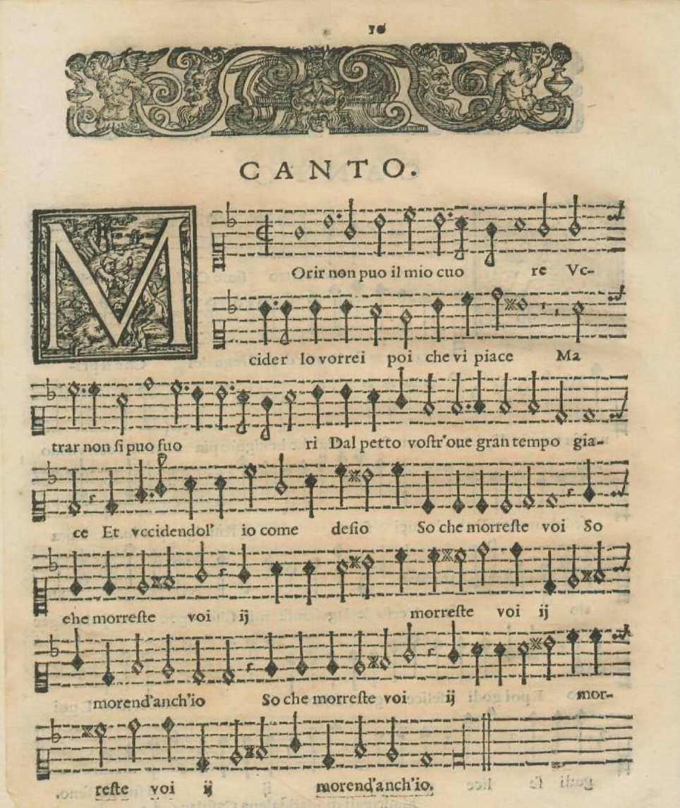

Answer; On the first line the first note is in disjunct motion.

Selected Coordinates844, 1235Clear
10 points

QUESTION 2
- In this image, you can see the original musical score for the “canto” (or soprano) part of this piece. Look closely at the melody in the last line of music and click where you see a very wide leap between two notes, a form of disjunctmotion. (For your answer to be recorded correctly, you should simply click on one of the two notes involved in this very wide leap. There are multiple correct answers!)

Answer; On the last line the third and fourth note on the last line have a very wide leap.
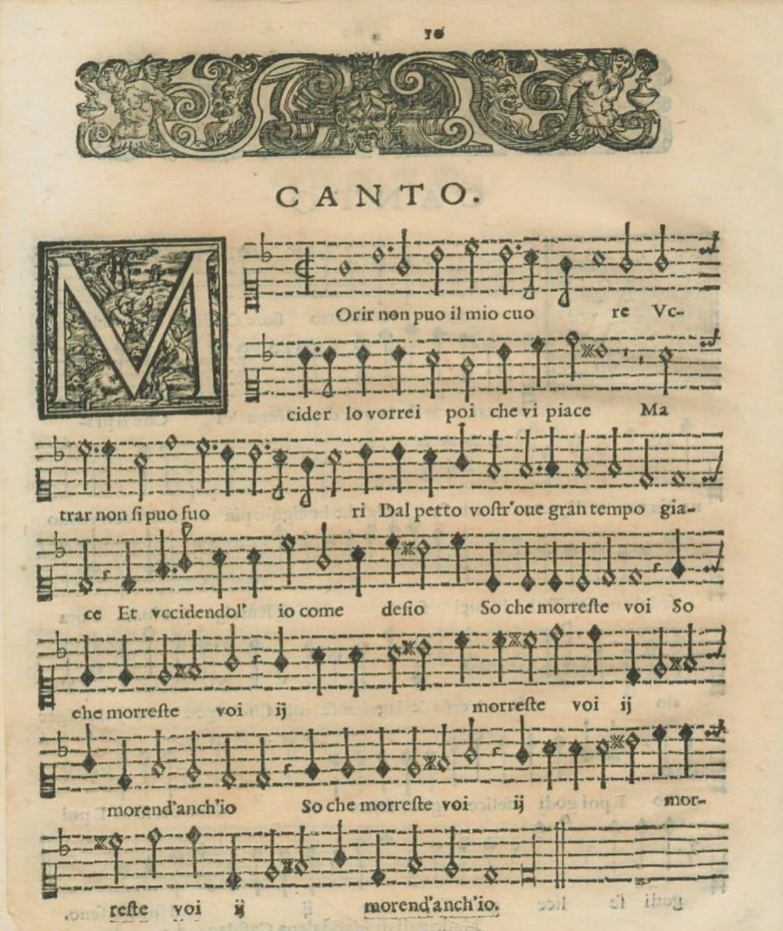

Selected CoordinatesClear
10 points

QUESTION 3
- In this image, you can see the original musical score for the “canto” (or soprano) part of this piece. Look closely at the melody in the first line of music and click where you see conjunct motion. (For your answer to be recorded correctly, you should simply click on one of the notes where you see conjunct motion. There are multiple correct answers!)

Answer; On the first line the seventh note is in conjunct motion.

Selected CoordinatesClear
10 points

QUESTION 4
- In this image, you can see the original musical score for the “canto” (or soprano) part of this piece. Look closely at the melody in the last line of music and click anywhere you see conjunct motion. (For your answer to be recorded correctly, you should simply click on one of the notes where you see conjunct motion. There are multiple correct answers!)

Answer; On the last line the ninth note is in conjunct motion
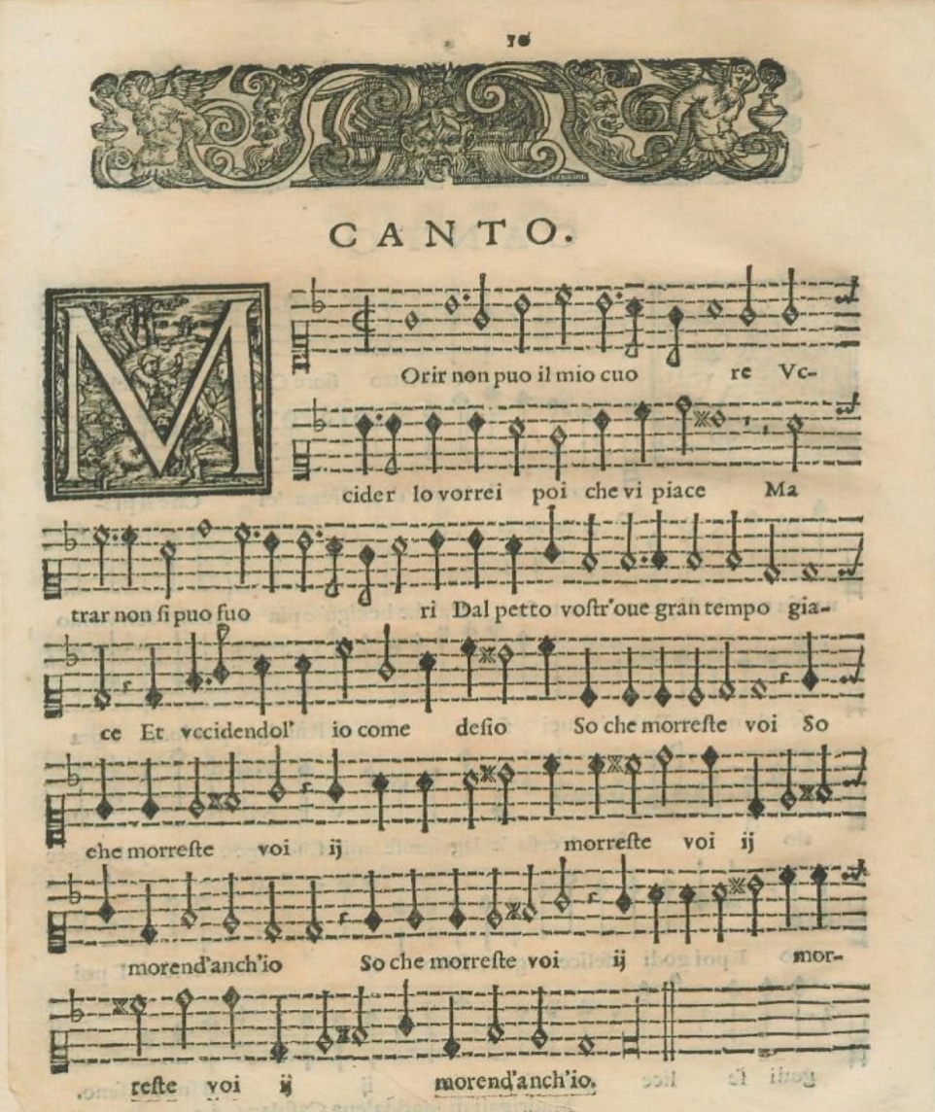

Selected CoordinatesClear
10 points

QUESTION 5
- After studying the modern musical score (which features all four parts) and listening to the recording—both of which are available in the Exam #1 folder on BlackBoard—how would you describe the composer’s approach to melody?

 | A. | the melody features almost entirely conjunct motion
 | B. | the melody features almost entirely disjunct motion
 | C. | the melody features both disjunct and conjunct motion
 | D. | none of the above
10 points

QUESTION 6
- How would you describe the texture at 00:01-00:15 of the recording (see Exam #1 folder on BlackBoard)?

 | A. | monophonic
 | B. | polyphonic
 | C. | homophonic
 | D. | heterophonic
10 points

QUESTION 7
- How would you describe the texture at 00:16-00:25 in the recording (see Exam #1 folder on BlackBoard)?
 | A. | monophonic
 | B. | polyphonic
 | C. | homophonic
 | D. | heterophonic
10 points

QUESTION 8
- How would you describe the texture at 00:26-00:40 in the recording (see Exam #1 folder on BlackBoard)?
 | A. | monophonic
 | B. | polyphonic
 | C. | homophonic
 | D. | heterophonic
10 points

QUESTION 9
- How would you describe the texture at 00:42-1:00 in the recording (see Exam #1 folder on BlackBoard)?
 | A. | monophonic
 | B. | polyphonic
 | C. | homophonic
 | D. | heterophonic
10 points

QUESTION 10
- How would you describe the texture at 1:00-1:58 in the recording (see Exam #1 folder in BlackBoard)?
 | A. | monophonic
 | B. | polyphonic
 | C. | homophonic
 | D. | heterophonic
10 points

QUESTION 11
- Throughout this piece, the text setting is mostly:
 | A. | melismatic
 | B. | neumatic
 | C. | syllabic
10 points

QUESTION 12
- How would you describe the rhythmic patterns in this piece?
 | A. | the rhythmic patterns in this piece follow the structure of the poem
 | B. | the rhythmic patterns in this piece are independent from the structure of the poem
10 points

QUESTION 13
- How would you describe the form of this piece?
 | A. | strophic
 | B. | through-composed
10 points

QUESTION 14
- What performing forces are required to perform this piece? Please select all that apply.

 | A. | soprano (male or female)
 | B. | alto
 | C. | tenor
 | D. | bass
10 points

QUESTION 15
- In the recording, the singers perform without accompaniment, a performance practice we usually describe using an Italian phrase. What is this phrase?
 | A. | accelerando
 | B. | andante
 | C. | a capella
 | D. | a piacere
10 points

QUESTION 16
- The text of “Morir non può il miocuore” (“My heart cannot die”) explores two lovers’ desire for and fear of death. The lovers’ fear of death—and thus separation from the beloved—seems straightforward, but their desire for death only makes sense when we remember the dual meaning of the Italian word “morire” (“to die”). Aside from its literal meaning, what else was “morire” (“to die”) widely known to mean during this era?
 | A. | to laugh
 | B. | to weep
 | C. | to fight
 | D. | to orgasm
10 points

QUESTION 17
- How does the composer’s setting of the poetic text depict the desire for “death” (in its second sense)?
 | A. | the notes sung by each voice are very close together and sometime even overlap with one another, suggesting the physical proximity of the lovers
 | B. | the voices ascend toward a musical climax near the end of the piece, mimicking sexual climax
 | C. | both A and B
10 points

QUESTION 18
- During this era, what musical genre was well-known for its use of words with multiple meanings?

 | A. | madrigal
 | B. | motet
 | C. | Mass
10 points

QUESTION 19
- Based on what you can glean about the genre of this piece based on the text and music, what was its intended function?
 | A. | This piece was intended to be performed in a sacred environment by professional church musicians
 | B. | This piece was intended to be performed in a sacred environment by the church congregation
 | C. | This piece was intended to be performed in a secular environment (such as a home) by amateur and/or professional musicians
10 points

QUESTION 20
- The harmony becomes dissonant on expressive and emotional words like “cuore” (heart), “piace” (to please/to give pleasure), “fuore” (to tear out), “giace” (to dwell), and especially “moreste” (to die). How do we typically describe this kind of relationship between the music and the text, in which the music reflects the meaning of the words?

 | A. | word-painting
 | B. | madrigalism
 | C. | both A and B
10 points

QUESTION 21
- As you’ve surely noticed, the original musical score for this piece (the “canto” part of which was shown in the first few questions) was printed rather than hand-written. Based on what you have discerned about the genre of this piece as well as what you know about when music printing technologies emerged, when must this piece have been published?

 | A. | before 1440
 | B. | between about 1440 and 1500
 | C. | after 1501
10 points

